NAME: MONIKA.B
REG. NO: 192571002

EXPERIMENT – 21
MYSQL String Functions- SPACE, SUBSTR, UPPER, LOWER, TRIM, LENGTH
SPACE, SUBSTR, UPPER, LOWER:

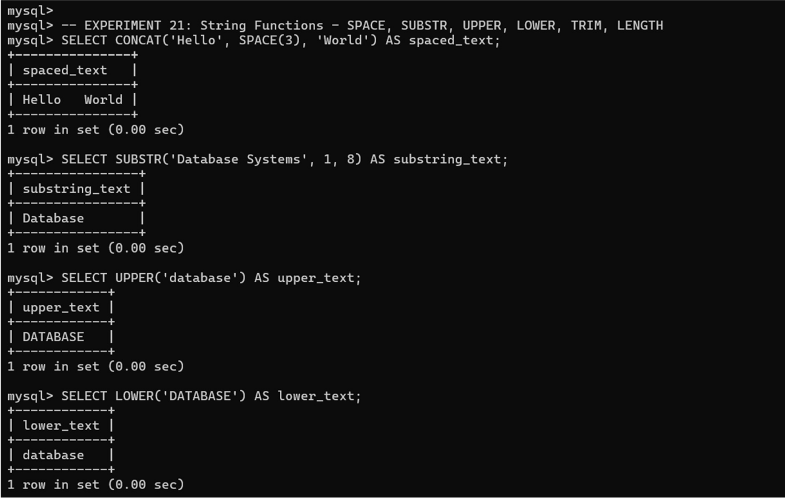

TRIM, LENGTH:

